## Parent Connections: Kids A-Z

Strengthen the school-to-home Connection with new updates from Learning A-Z

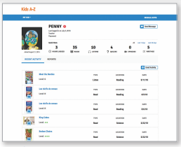

### Updated Parent Portal

Monitor your child’s progress and send your child encouraging messages, all from one centralized area within Kids A-Z

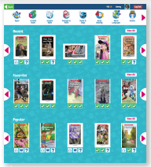

### Personalized Reading Room

The Raz-Plus and Raz-Kids Reading Rom now makes it easier to find level-appropriate books by topic, category, and popularity.

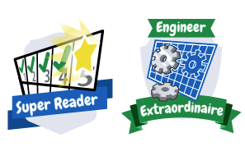

### New Badges

New Learning A-Z badges instantly reward students for achieving specific milestones, incentivizing them to complete more activities.

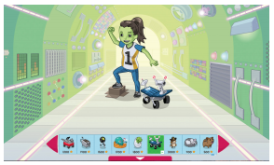

### Customizable Student Avatars

The new Avatar Builder motivates students to complete more activities in Kids A-Z, so they can build their own unique avatar.